Championing members of the Race to Zero

The Race to Zero
The Race to Zero is a UN-backed, global campaign to rally leadership and support from all non-state actors for a healthy, resilient, zero carbon recovery.
All members are committed to the same overarching goal: halving emissions by 2030 and achieving net zero emissions by 2050 at the very latest.
The objective is to accelerate momentum around the shift to a decarbonized economy ahead of COP26. This will send governments a resounding signal that business, cities, regions, universities, and investors are united in meeting the Paris goals and creating a more inclusive and resilient economy.
The campaign is an exercise in radical collaboration, uniting net zero commitments from a range of leading networks and initiatives. Members of the Race to Zero now numbers over 3,000 companies, cities, regions, investors and universities, and covers over 15% of the global economy, 7% of total CO₂ emissions and 0.62 billion people.

Social media series
In the run-up to COP26, the Race to Zero is looking to celebrate ambition and encourage further action as part of critical efforts to reduce global warming to 1.5 degrees celsius.
The Race to Zero campaign is therefore inviting leading members of the campaign to submit video content to be shared across the Race to Zero’s social media channels, by partners, members, and supporting organisations.
The Race to Zero team will edit and package the content with appropriate Race to Zero branding, and reshare across social media channels in the run up to COP26.
The content should - where possible - feature the head of organisation (CEO / mayor / chancellor) or closest equivalent, and follow the suggested script and recording guidance below.
We recommend for effective content that the video stay under 45 to 60 seconds in length.

Script

We’re in the race for a better world - a zero carbon world.
A healthier, safer, fairer world.

[Example text:
At [x company], we’re committed to halving our emissions by 2030, and are working with our suppliers to decarbonize across our entire value chain. Since joining Race to Zero, we’ve…
As [mayor], I’m committed to making [x city / region] a healthier, more resilient [city / region]. Since joining the Race to Zero, we’ve…
At [x university] we take our responsibility as educators of the future generation very seriously. Since joining the Race to Zero, we’ve….
At [x investor] we’re committed to financing the transition to a zero carbon economy. Since joining the Race to Zero, we’ve...]

We joined the Race through [e.g. Business Ambition for 1.5 / SME Climate Hub / etc.]
And we need more and more people to join, right now.
This is not about 2050, it’s about today.
Because together, we can do this.
And we’re already on the way.

Recording High Quality Video
The following guidance is to help record video at the highest quality possible. This assumes you will record it as part of a Zoom call, but this can also be done through the camera of the laptop or other recording device such as a smartphone. We recommend you choose the option with the best quality camera, and follow the guidelines below.
You’ll need to toggle on a few different settings in the Zoom desktop app preferences to get set up correctly. These settings can all be found in the ‘Video Settings’ menu. This is found on the camera button through clicking an up arrow just beside it.
Please note locations of settings vary sometimes according to the device or account type you have. If you can’t find what you’re looking for please get in touch with Ben or Ellie from Empower or consult the Zoom support site.

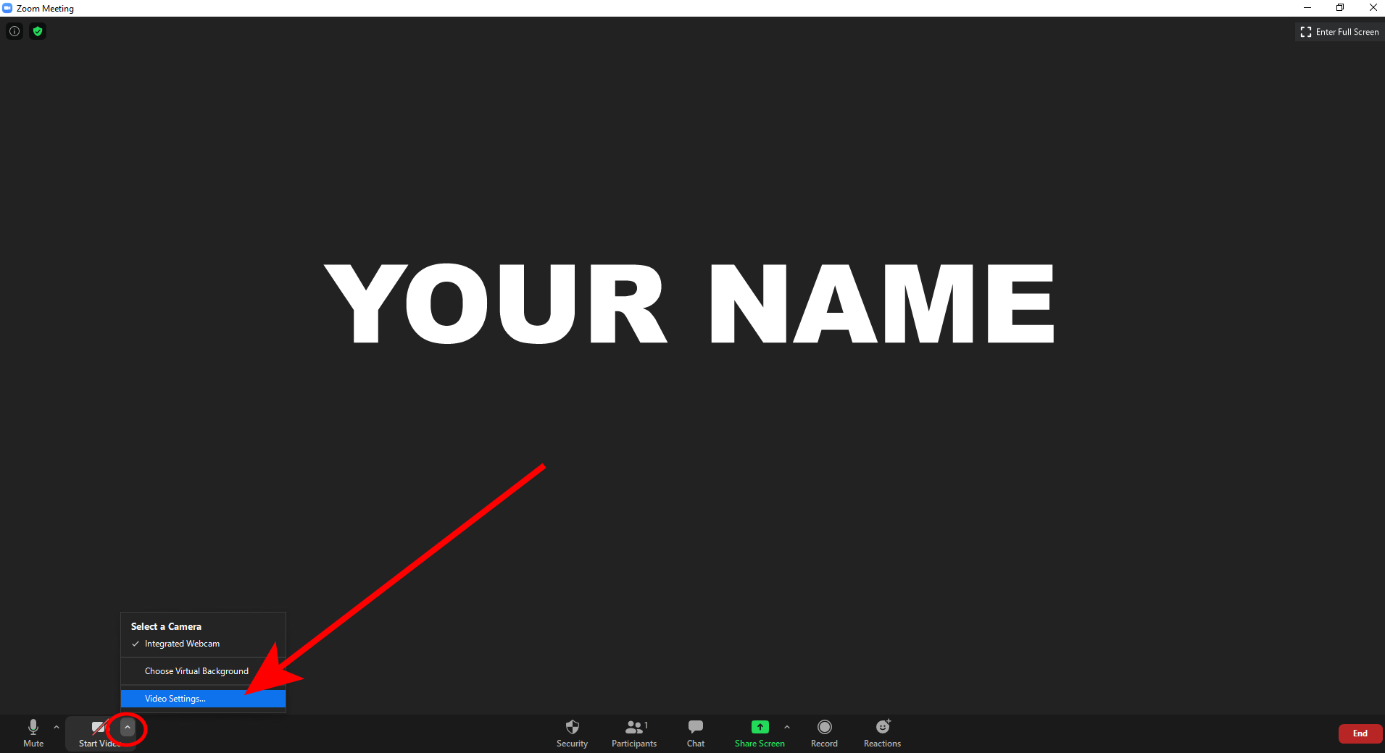

First you need to change the video settings to HD and check your ratio (the dimensions of your video) is the standard 16:9. This is under the Video settings selected from the left hand menu bar.
In the video settings ensure both Enable HD and 16:9 widescreen aspect ratio are selected.

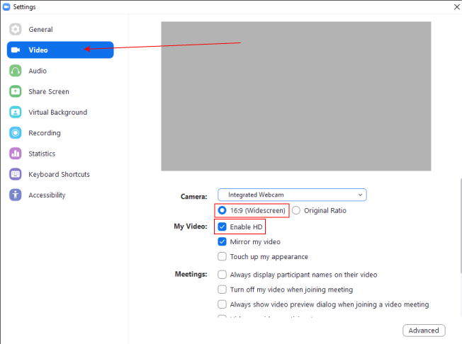

More info here.

Then select the Recording settings from the left hand menu bar.
And select:
- Optimise for third party video editor
- Record separate audio file for each participant
- Record video during screen sharing
  - If you would prefer to also have your presentation recorded select this option also.

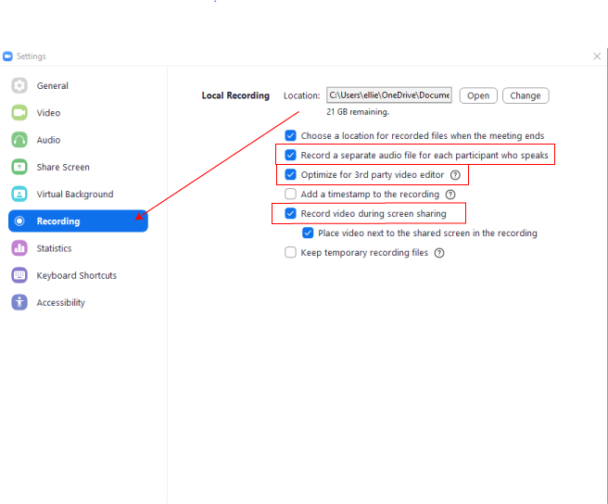

Once you have changed these settings, to record a meeting you simply press Record > Record on this Computer in the on-screen controls.
You can also record in several different ‘modes’ including active speaker mode where only the speaker is shown. This is what we recommend.

Local recording
More advanced accounts (those with paid subscriptions) will also include an option to record via the cloud. This can be a helpful backup option should something go wrong, but local recording is preferable as a first option.

Other recording methods
You can also use the inbuilt recording options such as QuickTime (mac) or the Camera app (Windows). This will not record the Zoom call itself, only what you do during it, but if you set it going before you join your call it will have similar results, only usually with higher quality (Zoom is limited to 720p). If this is something you want to try, test beforehand or ask a member of the Empower team to help you.

Recording Set-up
Position
Position your laptop or phone so it is at eye level. This will be the most flattering angle.

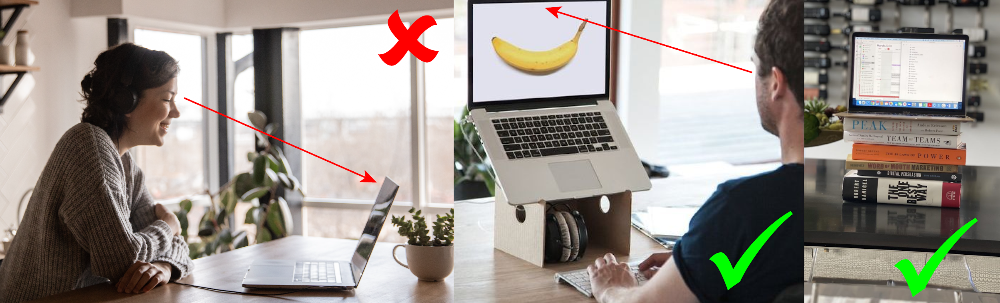

Orientation
This is very important. If you’re joining on your phone, make sure you are holding it sideways, so that you are framed landscape. If you hold your camera upright, you will produce a vertical video or will appear with black bars either side of you. This will be very difficult to correct in the edit.

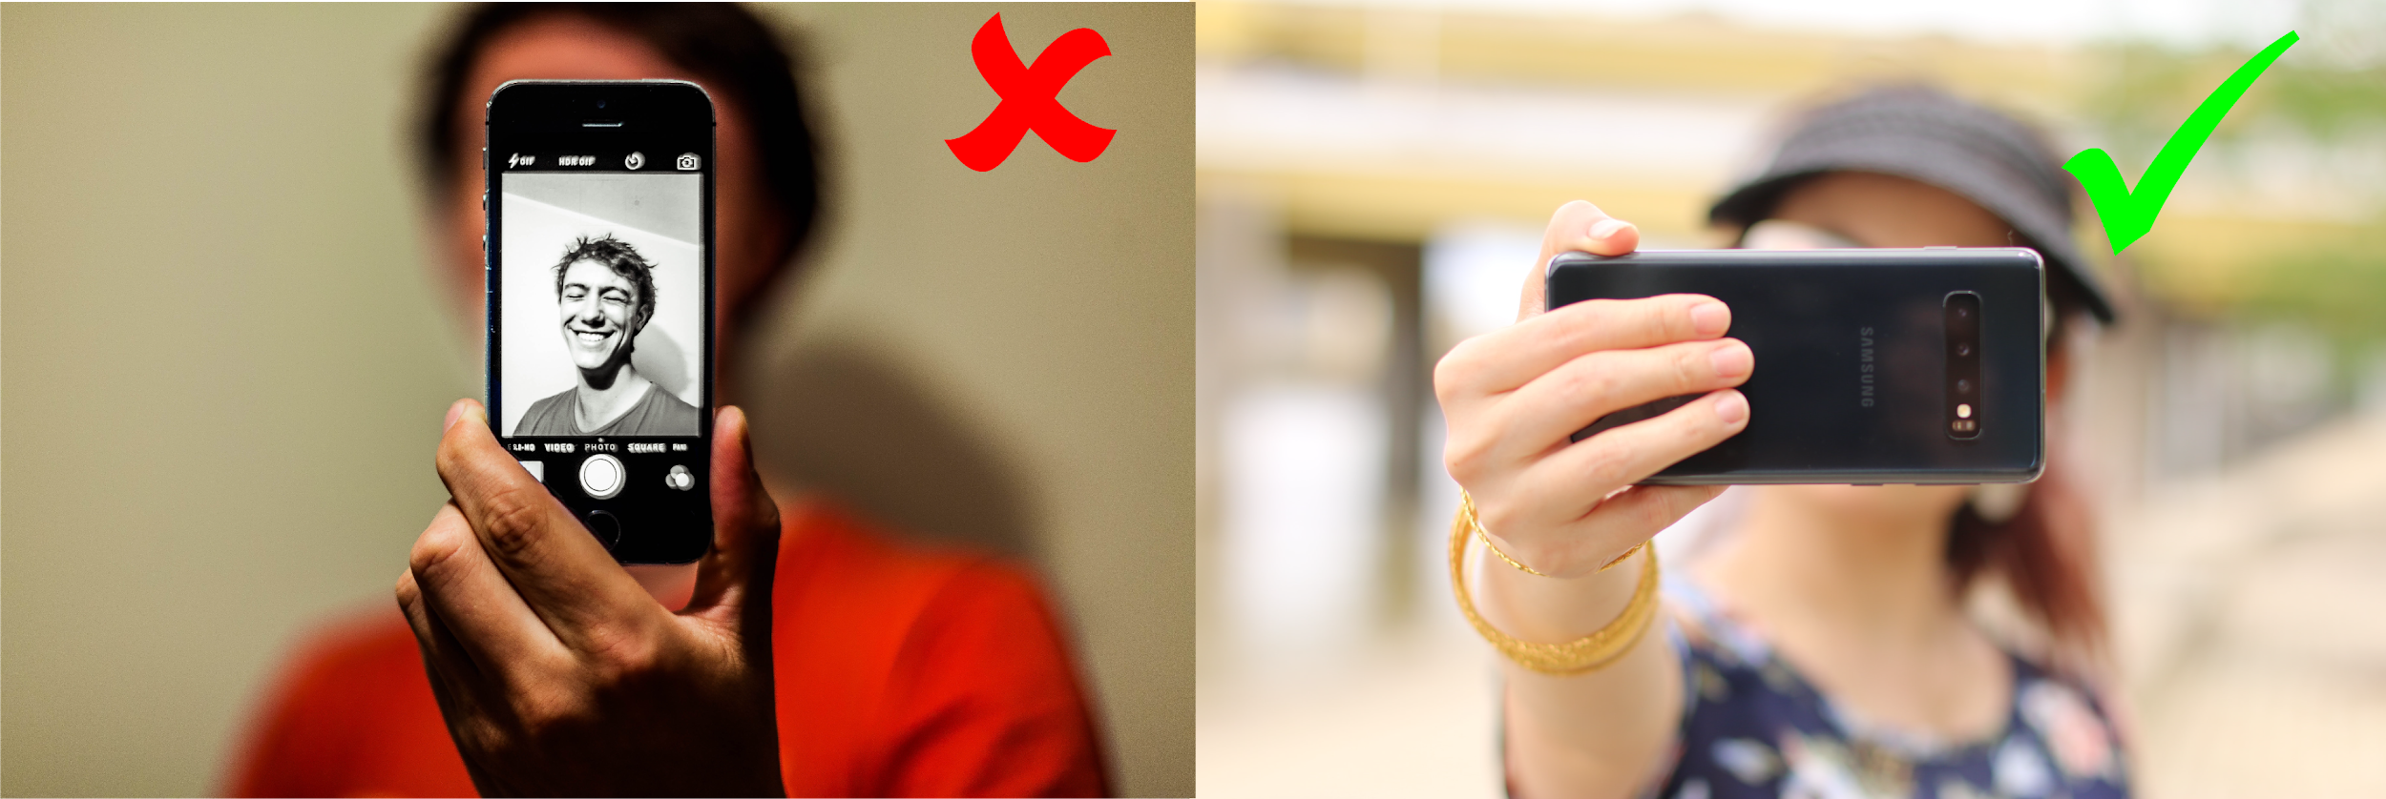

Framing
Make sure your head is not cut off and you are centred in the middle of the frame.

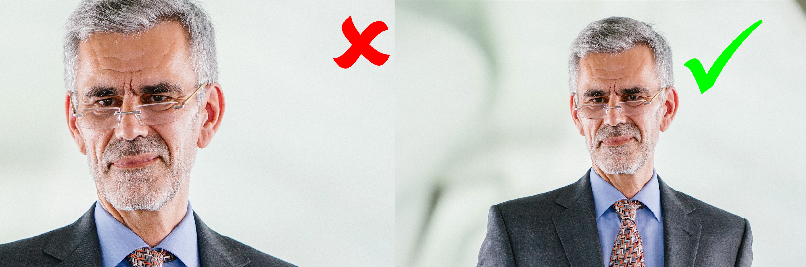

Light
If you have a light source, such as a window, make sure it is in front of you. A light source behind you will darken and obscure your face and emphasise the background instead.

Sound
Find someone quiet where you will not be distrubed. Turn off any background noise such as air conditioning, buzzing computers etc. Shut any windows which could let in noise from the street outside.
Don’t make noise near to the mic, such as fiddling with clothing or pens, or typing. This will obscure and distort your speech.

Other Tips
1. Camera Angle
Look into the camera lens while talking to make eye contact with your audience.
2. Attire
Recommend avoiding busy patterns on shirts and ties. Plain shirts and jackets work well.
3. Positioning
It’s best to sit on a chair, for comfort plus you are more stationary / move around less than if you were standing. When viewing yourself on the screen, try to position yourself so there is a gap between your head and the top of the screen, plus enough of a gap below your head and the bottom of the screen to see some of your upper body. Imagine what a TV interviewee looks like on screen and try to match that.

